Project 2: Cryt-Arithmetic

James Halladay

For Programming Languages

Oct 4th, 2021

We ran a Crypt-Arithmetic analysis of three problems:

1. EAT + THAT = APPLE
2. SEND + MORE = MONEY
3. CROSS + ROADS = DANGER

This gave us the results found below

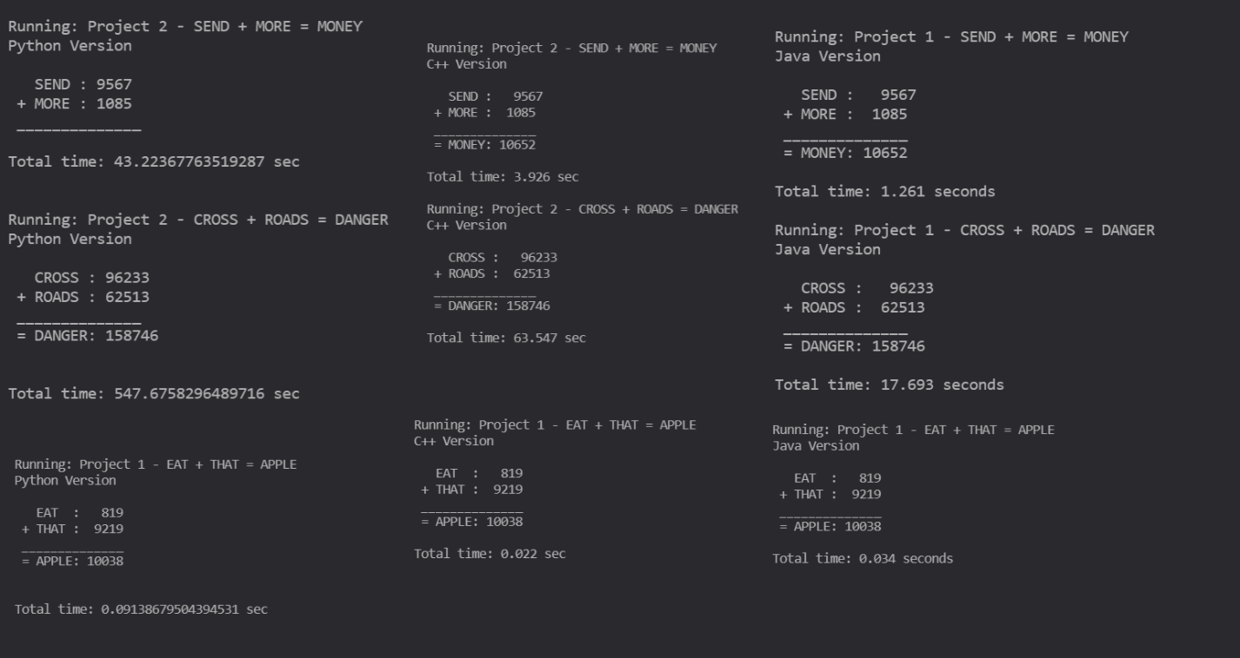

Graphing our results gives us the graph

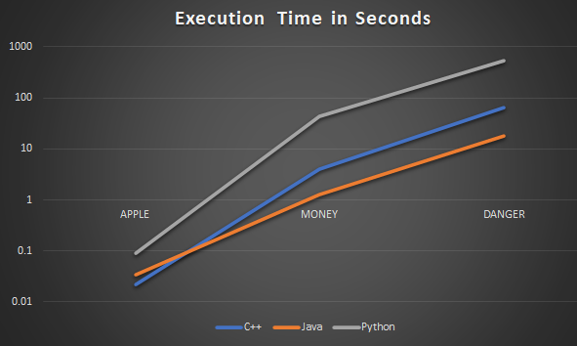

Surprisingly, this has shown that the algorithm performs best in its Java implementation. While it is no surprise that python is the worst performer in each instance, Java only lags behind in the most basic problem, suggesting that C++ only beat java due to overhead. Once the problem became complex enough, the margin caused by that overhead disappears and java outperforms C++.